**SMART FASHION RECOMMENDER APPLICATION**

**PREPARE EMPATHY MAP**

TECHNICAL ARCHITECTURE:-

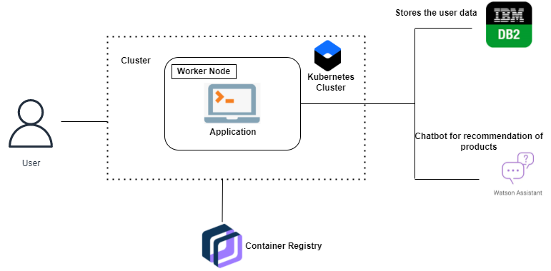

Fig 1: Architecture of Overall way of Processing Model

Fig 1: Architecture of Overall way of Processing Model.